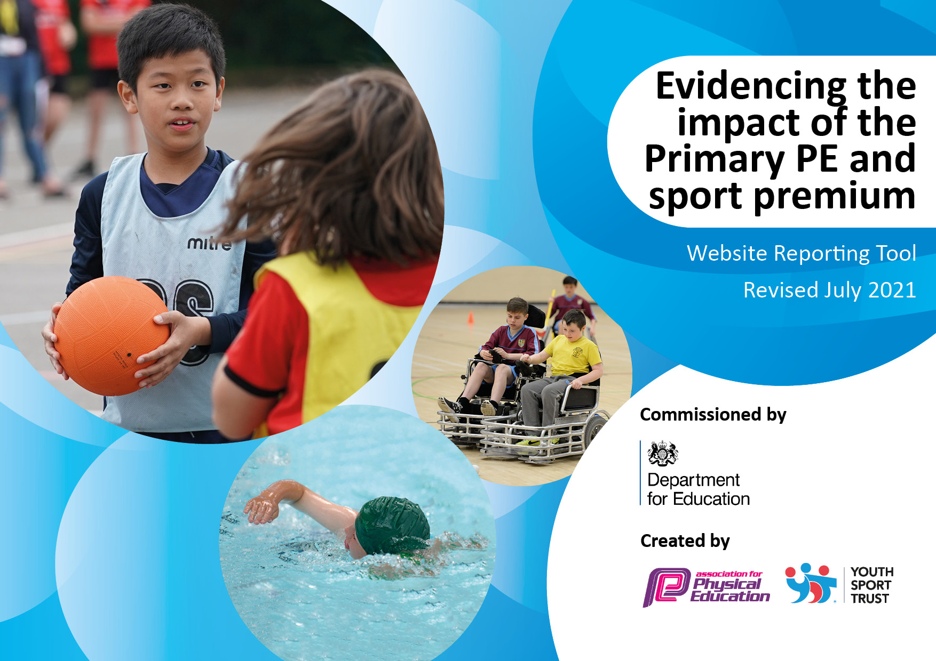
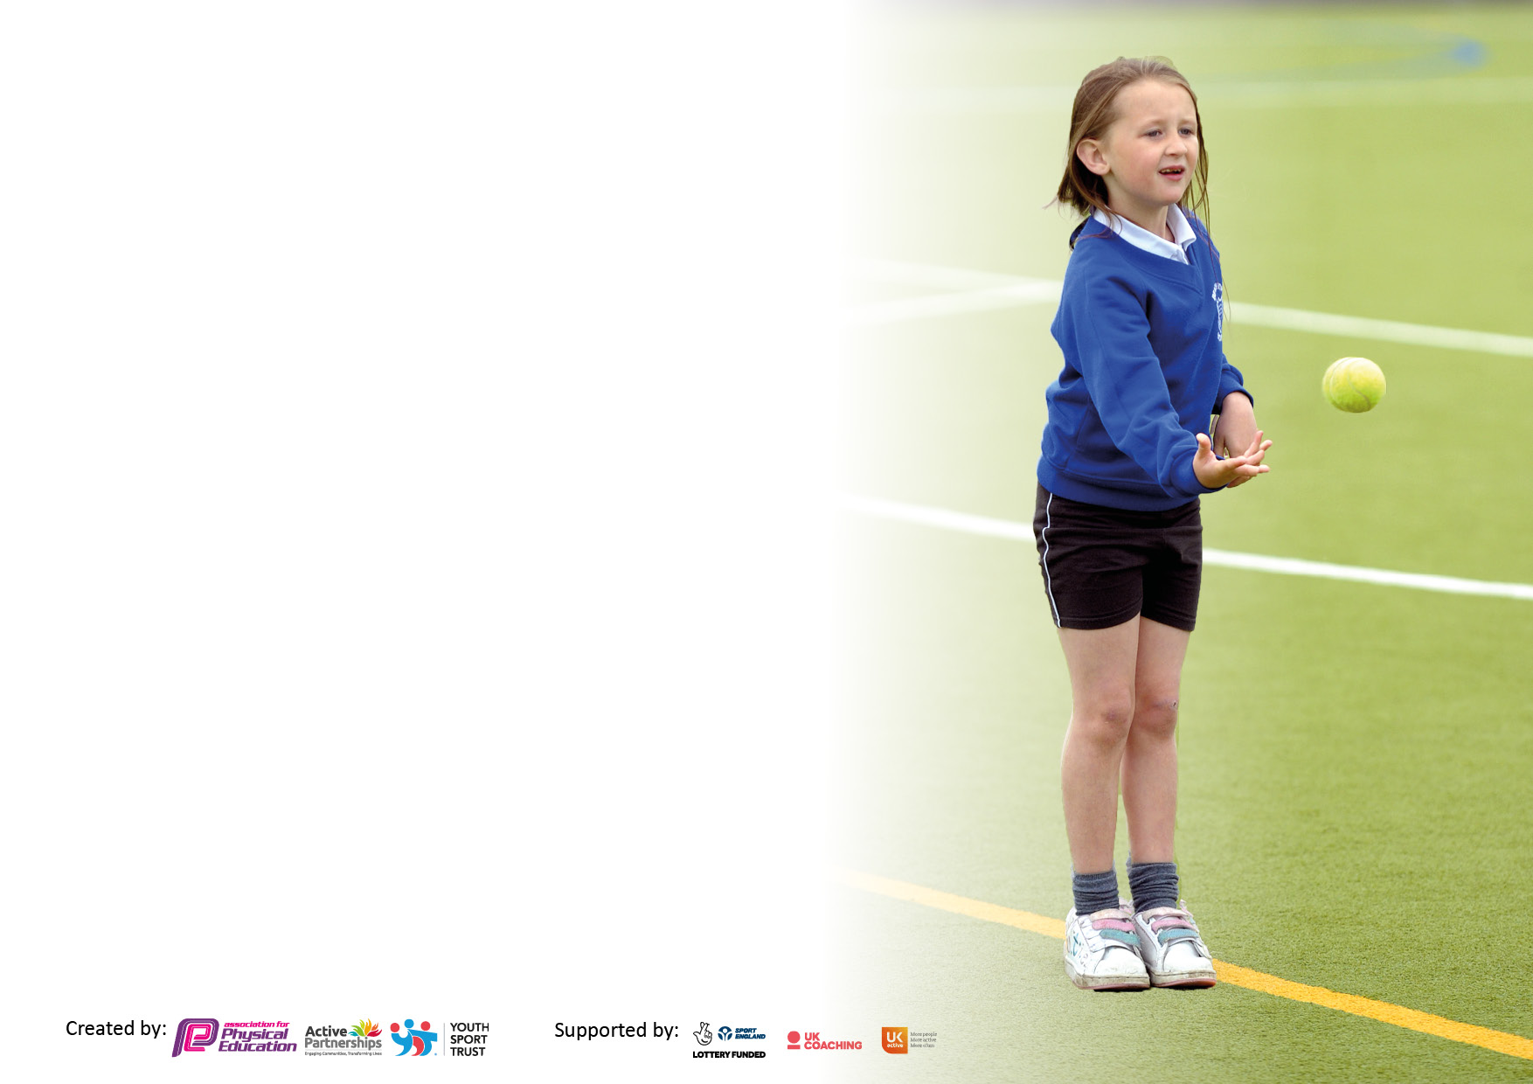

It is important that your grant is used effectively and based on school need. The Education Inspection Framework makes clear there will be a focus on ‘whether leaders and those responsible for governors all understand their respective roles and perform these in a way that enhances the effectiveness of the school’.

Under the Quality of Education Ofsted inspectors consider:
Intent - Curriculum design, coverage and appropriateness
Implementation - Curriculum delivery, Teaching (pedagogy) and Assessment
Impact - Attainment and progress

To assist schools with common transferable language this template has been developed to utilise the same three headings which should make your plans easily transferable between working documents.

Schools must use the funding to make additional and sustainable improvements to the quality of Physical Education, School Sport and Physical Activity (PESSPA) they offer. This means that you should use the Primary PE and sport premium to:

- Develop or add to the PESSPA activities that your school already offer
- Build capacity and capability within the school to ensure that improvements made now will benefit pupils joining the school in future years
- The Primary PE and sport premium should not be used to fund capital spend projects; the school’s budget should fund these.

Pleasevisitgov.ukfortherevisedDfEguidanceincludingthe5keyindicatorsacrosswhichschoolsshoulddemonstrate animprovement.Thisdocumentwillhelpyoutoreviewyourprovisionandtoreportyourspend.DfEencouragesschools to use this template as an effective way of meeting the reporting requirements of the Primary PE and sport premium.

We recommend you start by reflecting on the impact of current provision and reviewing the previous spend.

Schools are required to publish details of how they spend this funding, including any under-spend from 2019/2020, as well as on the impact it has on pupils’ PE and sport participation and attainment. All funding must be spent by 31st July 2022.

We recommend regularly updating the table and publishing it on your website throughout the year. This evidences your ongoing self-evaluation of how you are using the funding to secure maximum, sustainable impact. Final copy must be posted on your website by the end of the academic year and no later than the 31st July 2021. To see an example of how to complete the table please click HERE.
Created by: Supported by:

Details with regard to funding
Please complete the table below.

Total amount carried over from 2021/22 | £ 0
Total amount allocated for 2020/21 | £ 16,320.00
How much (if any) do you intend to carry over from this total fund into 2021/22? | £ 0
Total amount allocated for 2021/22 | £ 16,320.00
Total amount of funding for 2021/22. To be spent and reported on by 31st July 2022. | £ 16,320
Swimming Data
Please report on your Swimming Data below.

Meeting national curriculum requirements for swimming and water safety.  N.B. Complete this section to your best ability. For example you might have practised safe self-rescue techniques on dry land which you can then transfer to the pool when school swimming restarts.  Due to exceptional circumstances priority should be given to ensuring that pupils can perform safe self rescue even if they do not fully meet the first two requirements of the NC programme of study | ZERO
What percentage of your current Year 6 cohort swim competently, confidently and proficiently over a distance of at least 25 metres?  N.B. Even though your pupils may swim in another year please report on their attainment on leaving primary school at the end of the summer term 2021.  Please see note above | 0%
What percentage of your current Year 6 cohort use a range of strokes effectively [for example, front crawl, backstroke and breaststroke]?  Please see note above | 0%
What percentage of your current Year 6 cohort perform safe self-rescue in different water-based situations? | 0%
Schools can choose to use the Primary PE and sport premium to provide additional provision for swimming but this must be for activity over and above the national curriculum requirements. Have you used it in this way? | Yes/No

Action Plan and Budget Tracking
Capture your intended annual spend against the 5 key indicators. Clarify the success criteria and evidence of impact that you intend to measure to evaluate for pupils today and for the future.
Academic Year: 2020/21 | Total fund allocated: £ 16,320.00 | Date Updated:
Key indicator 1: The engagement of all pupils in regular physical activity – Chief Medical Officers guidelines recommend that primary school pupils undertake at least 30 minutes of physical activity a day in school |  |  |  | Percentage of total allocation:
 |  |  |  | £11,811 72%
Intent | Implementation |  | Impact
Your school focus should be clear what you want the pupils to know and be able to do and about  what they need to learn and to  consolidate through practice: | Make sure your actions to achieve are linked to your intentions: | Funding allocated: | Evidence of impact: what do pupils now know and what can they now do? What has changed? | Sustainability and suggested next steps:
Forest school gives children the opportunities to take supported risks; climbing, using tools, fire etc. As forest school is child led it helps to develop self-esteem, physical, emotional and cognitive skills. Overall holistic development of the whole child is at the heart of forest school.  To create an engaging interactive environment outside where children can enjoying activities which develop proprioception and vestibular skills  To enable all students to access weekly rebound therapy sessions. | For 1 member of staff to achieve level 3 leadership in Forest school.  For 1 member of staff to achieve a certificate in supporting children with PMLD in outdoors.  Purchase a hoist for the trampoline.  To repair the trampoline base. | £8560.00  £595.00  £2156.00  £500.00 | Many of our students on the autistic spectrum have shown that they are calmer during outdoor activities. It has been evidenced that students who have PMLD, become more relaxed, alert, happy & show more curiosity in an outdoor environment. When outdoors we find we enter a different level of learning. There is receptiveness, intensive interaction increases.  All classes have access to immediate outdoor learning areas and a designated forest school area.  Most classes take part in rebound therapy on a weekly basis. | We need to continue to widen the opportunities and experiences for our students to engage with the outdoors. Staff need opportunities to share emerging ideas and support each other with methods for concise recording/evidencing.  NEXT STEPS  All classes to have a timetabled slot of a minimum of 45 minutes, delivered by the forest school lead.  All classes to have a timetabled slot of a minimum of 90 minutes, delivered by a fully qualified rebound therapist.  ALL to access 30 minutes outdoor learning on a daily basis, during snack/lunch time, in addition to structured lessons
Key indicator 2: The profile of PESSPA being raised across the school as a tool for whole school improvement |  |  |  | Percentage of total allocation:
 |  |  |  | £1500.00 9.2%
Intent | Implementation |  | Impact
Your school focus should be clear what you want the pupils to know and be able to do and about  what they need to learn and to  consolidate through practice: | Make sure your actions to achieve are linked to your intentions: | Funding allocated: | Evidence of impact: what do pupils now know and what can they now do. What has changed? | Sustainability and suggested next steps:
Member of teaching staff to take specific responsibility and accountability for the day-to-day management and organisation of Sports Premium | Named staff to be put in position.  Research on the sports development needed within school.  Put ideas forward for sports/physical activities suitable for students | £1500.00 | - A range of sports and physical activities suited to pupils needs were be provided and monitored | School website, Facebook and school display have showcased students achievements in PE and sport.  NEXT STEPS  To Up skill all teaching staff to ensure they are helping the pupils learn all about sport increase their physical literacy and develop important motor skills  PE Training for staff working with pupils on the Explore and Aspire curriculum.  Increase in staff knowledgeable and confidence in delivering quality PE sessions ensuring that the pupils become more confident, assertive, independent and self-controlled.

Key indicator 3: Increased confidence, knowledge and skills of all staff in teaching PE and sport |  |  |  | Percentage of total allocation:
 |  |  |  | £665.00 4%
Intent | Implementation |  | Impact
Your school focus should be clear | Make sure your actions to | Funding | Evidence of impact: what do | Sustainability and suggested
what you want the pupils to know | achieve are linked to your | allocated: | pupils now know and what | next steps:
and be able to do and about | intentions: |  | can they now do? What has
what they need to learn and to |  |  | Changed?
consolidate through practice:
In order to provide our children with more movement, we need to provide them with the motivation to move. We have to include functional mobility practices in activities where children will be motivated to move, for example, walking into assembly, to a room full of their friends.  Movement is the primary foundation for learning. There are 3 underpinnings of move: motivation, progression and opportunity. | MOVE trainer reaccreditation  MOVE membership | £490.00  £175.00 | Since September 2021 we have gone from having 4 students on the programme, to having 10. The 10 students on the programme have all shown progress in their physical development and this has impacted on the student’s engagement in learning activities throughout their school day.  ALL members of staff have attended the MOVE awareness training sessions in school. (Teachers, SIA’s, IA’s & Mid-day supervisors), SLT & Governors had MOVE awareness via a webinar, these was shared via email.  x6 assessment profiles completed (in class)  Training records are up to date electronic records on server  Move incorporated in lesson plans  A MOVE team was created to ensure sustainability throughout the school. | Training records are up to date electronic records on server  Move incorporated in lesson plans  A MOVE team was created to ensure sustainability throughout the school.  NEXT STEPS  We ensure more students can access the MOVE programme.  Achieve MOVE Bronze quality mark  Every class to have all staff at least 1 MOVE practitioner trained.  Progression shown on server/EFL to enable us to collect/analyse/evidence impact of MOVE.  Staff confident in prompt adjustment plans  Whole school MOVE day  Integrated throughout the school day/planning/PLIMS/PLOMS, related to EHCP.
Key indicator 4: Broader experience of a range of sports and activities offered to all pupils |  |  |  | Percentage of total allocation:
 |  |  |  | £2120.00 13%
Intent | Implementation |  | Impact
Your school focus should be clear | Make sure your actions to | Funding | Evidence of impact: what do | Sustainability and suggested
what you want the pupils to know | achieve are linked to your | allocated: | pupils now know and what | next steps:
and be able to do and about | intentions: |  | can they now do? What has
what they need to learn and to |  |  | Changed?
consolidate through practice:
Additional achievements:  Students have access to a range of wider community activities which can involve the climbing wall, caving, the ropes and equipment for assault courses which are adaptable for the students’ needs. | Students have access to a number of inclusive activities at different points during the year from an external provider.  Opportunity for a residential and access to a greater variety of outdoor activities | £2120.00 | • Improved core and limb strength  • Develop new skills  • Improved fitness  • Acquisition of new physical skills  • Increased confidence and self-esteem  • Students experience a different environment  • Sense of adventure, whilst improving teamwork communication and physical awareness | Continue to enhance quality of PE sessions by employing sports coaches for some delivery of lessons as well as working alongside school staff.  NEXT STEPS  Further establish visits to local sporting facilities e.g. Derbyshire county council, leisure centres

Key indicator 5: Increased participation in competitive sport |  |  |  | Percentage of total allocation:
 |  |  |  | £225.00 1.4%
Intent | Implementation |  | Impact
Your school focus should be clear | Make sure your actions to | Funding | Evidence of impact: what do | Sustainability and suggested
what you want the pupils to know | achieve are linked to your | allocated: | pupils now know and what | next steps:
and be able to do and about | intentions: |  | can they now do? What has
what they need to learn and to |  |  | changed?
consolidate through practice:
Offer a range of sporting activities and experiences. | Mini Bus training to enable students to take part in sport activities outside of school.  Students increasingly confident to interact with others at events Increase participation in sporting activities, develop interests in sport and active lifestyle | £225.00 | Pupils have enjoyed engaging and learning new sports and activities through the support of Derby County’s community engagement coaches.  Greater awareness of sports available for staff to replicate  Increased confidence and self-esteem  A high energy work-out with simple commands and communication for ASD and ADHD students  Acquisition of new physical skills  Improved gross and fine motor skills Improved fitness | To ensure long term planning reflects a wider range of sports.  To maintain links with Derby county community engagement coaches.  NEXT STEPS  To consider options of outside agencies delivering sessions for students during PE slots.  Staff to learn from coaches who have been into school, e.g., table cricket or AVSSP coaches.

Signed off by
Head Teacher:
Date:
Subject Leader:
Date:
Governor:
Date:

