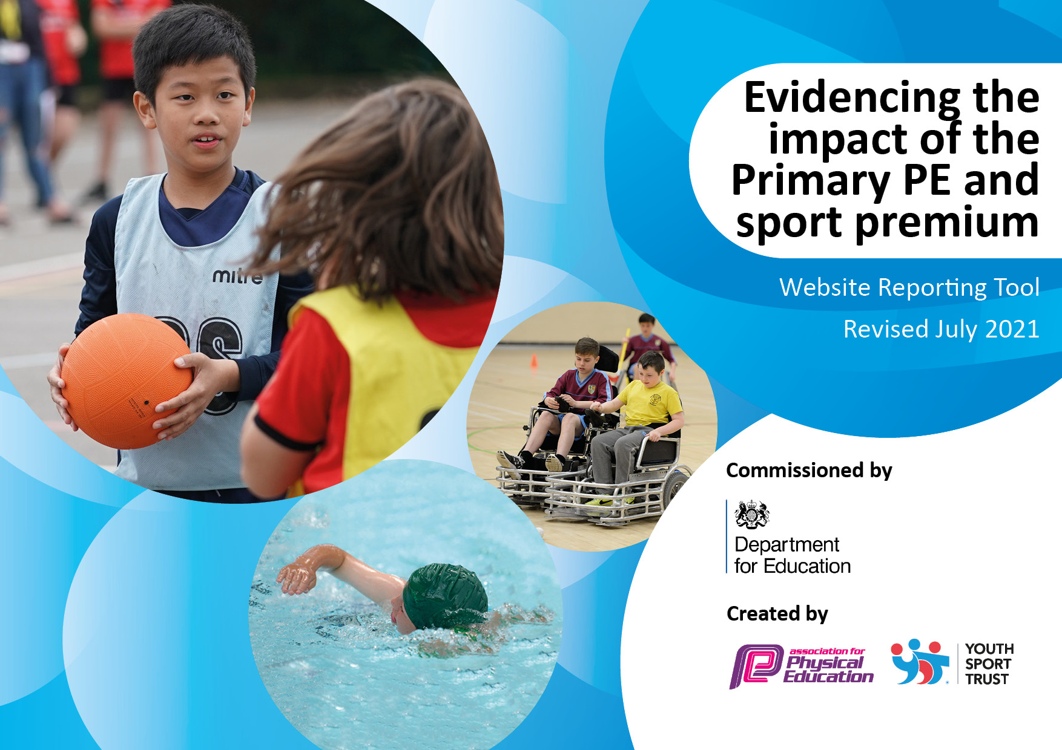
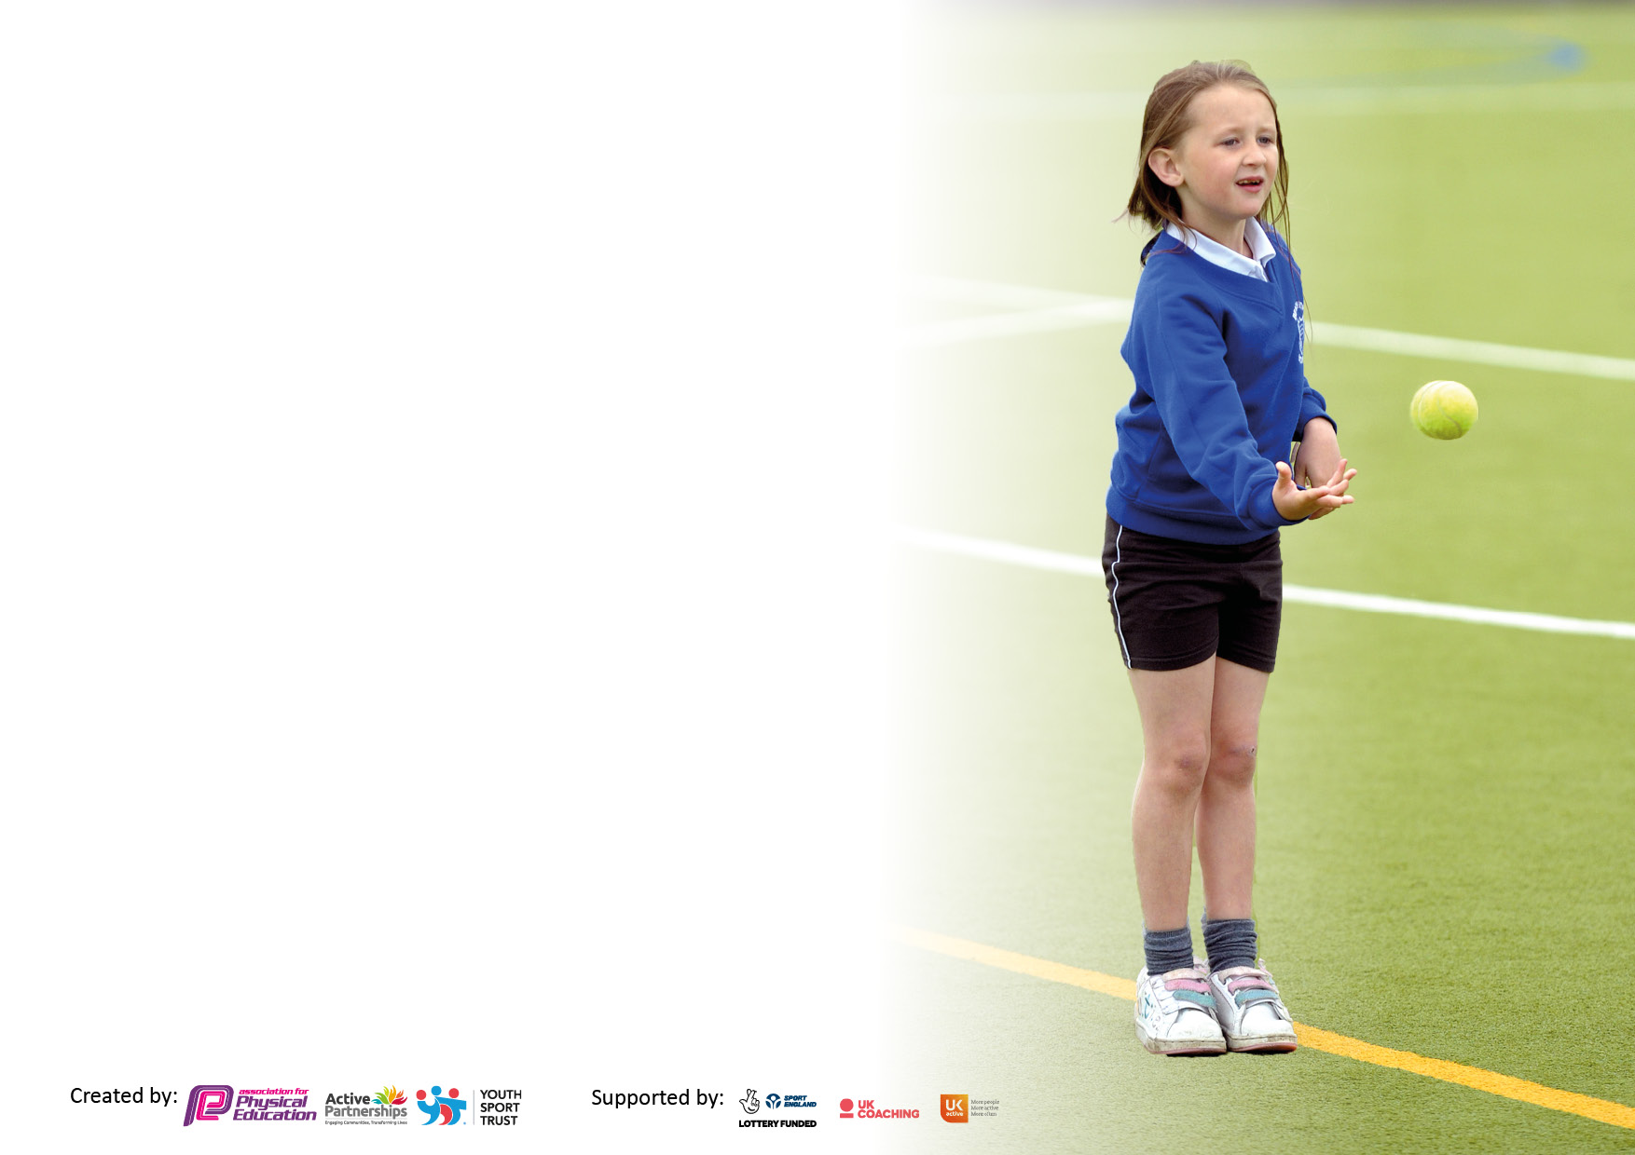

It is important that your grant is used effectively and based on school need. The Education Inspection Framework makes clear there will be a focus on ‘whether leaders and those responsible for governors all understand their respective roles and perform these in a way that enhances the effectiveness of the school’.

Under the Quality of Education Ofsted inspectors consider:
Intent - Curriculum design, coverage and appropriateness
Implementation - Curriculum delivery, Teaching (pedagogy) and Assessment
Impact - Attainment and progress

To assist schools with common transferable language this template has been developed to utilise the same three headings which should make your plans easily transferable between working documents.

Schools must use the funding to make additional and sustainable improvements to the quality of Physical Education, School Sport and Physical Activity (PESSPA) they offer. This means that you should use the Primary PE and sport premium to:

- Develop or add to the PESSPA activities that your school already offer
- Build capacity and capability within the school to ensure that improvements made now will benefit pupils joining the school in future years
- The Primary PE and sport premium should not be used to fund capital spend projects; the school’s budget should fund these.

Pleasevisitgov.ukfortherevisedDfEguidanceincludingthe5keyindicatorsacrosswhichschoolsshoulddemonstrate animprovement.Thisdocumentwillhelpyoutoreviewyourprovisionandtoreportyourspend.DfEencouragesschools to use this template as an effective way of meeting the reporting requirements of the Primary PE and sport premium.

We recommend you start by reflecting on the impact of current provision and reviewing the previous spend.

Schools are required to publish details of how they spend this funding, including any under-spend from 2019/2020, as well as on the impact it has on pupils’ PE and sport participation and attainment. All funding must be spent by 31st July 2022.

We recommend regularly updating the table and publishing it on your website throughout the year. This evidences your ongoing self-evaluation of how you are using the funding to secure maximum, sustainable impact. Final copy must be posted on your website by the end of the academic year and no later than the 31st July 2021. To see an example of how to complete the table please click HERE.
Created by: Supported by:

Details with regard to funding
Please complete the table below.

Total amount carried over from 2021/22 | £ 0
Total amount allocated for 2020/21 | £ 16,320.00
How much (if any) do you intend to carry over from this total fund into 2022/23? | £ 0
Total amount allocated for 2022/23 | £ 16,320.00
Total amount of funding for 2022/23. To be spent and reported on by 31st July 2023. | £ 16,320
Swimming Data
Please report on your Swimming Data below.

Meeting national curriculum requirements for swimming and water safety.  N.B. Complete this section to your best ability. For example you might have practised safe self-rescue techniques on dry land which you can then transfer to the pool when school swimming restarts.  Due to exceptional circumstances priority should be given to ensuring that pupils can perform safe self rescue even if they do not fully meet the first two requirements of the NC programme of study | ZERO
What percentage of your current Year 6 cohort swim competently, confidently and proficiently over a distance of at least 25 metres?  N.B. Even though your pupils may swim in another year please report on their attainment on leaving primary school at the end of the summer term 2021.  Please see note above | 0%
What percentage of your current Year 6 cohort use a range of strokes effectively [for example, front crawl, backstroke and breaststroke]?  Please see note above | 0%
What percentage of your current Year 6 cohort perform safe self-rescue in different water-based situations? | 0%
Schools can choose to use the Primary PE and sport premium to provide additional provision for swimming but this must be for activity over and above the national curriculum requirements. Have you used it in this way? | Yes/No

Action Plan and Budget Tracking
Capture your intended annual spend against the 5 key indicators. Clarify the success criteria and evidence of impact that you intend to measure to evaluate for pupils today and for the future.
Academic Year: 2022/23 | Total fund allocated: £ 16,320.00 | Date Updated: June 2023
Key indicator 1: The engagement of all pupils in regular physical activity – Chief Medical Officers guidelines recommend that primary school pupils undertake at least 30 minutes of physical activity a day in school |  |  |  | Percentage of total allocation:
 |  |  |  | 69.5%
Intent | Implementation |  | Impact
Your school focus should be clear what you want the pupils to know and be able to do and about  what they need to learn and to  consolidate through practice: | Make sure your actions to achieve are linked to your intentions: | Funding allocated: | Evidence of impact: what do pupils now know and what can they now do? What has changed?: | Sustainability and suggested next steps:
FOREST SCHOOL – MATTHEW  Forest school gives children the opportunities to take supported risks; climbing, using tools, fire etc. As forest school is child led it helps to develop self-esteem, physical, emotional and cognitive skills. Overall holistic development of the whole child is at the heart of forest school.  Ensure all students access a minimum of 2.5 hrs of activity each week. | • To employ a member of staff that is Level 3 trained Forest School lead.  • Planning for all curriculum Pathways and Avenues.  • Purchase of relevant equipment  • Set boundaries for pupils on safety  • Set weekly sessions for pupils to attend  • Start to roll out for whole school  To create a whole school timetable for forest school, swim, PE, Rebound Therapy, safe mobility room, music & dance. | £10,000  £1,348.48  £0:00 | All classes access forest school on a weekly basis.  Planning is in place for all sessions.  All equipment needed for this academic year has been purchased and used to enhance learning.  Timetable in place and shared with all staff.  All students receive some physical movement/exercise daily. This has been quality assured. These sessions, now include physio, swim, PE forest school, Dance massage, Rebound therapy, MOVE- through functional activities, cycling | Develop a lunchtime and after school club options to promote physical education to as many pupils outside of their regular timetable  Noticeboard in place.  Display regularly updated.  Employ and train a new forest leader, I additional member of staff that is familiar with our students and their learning styles.  Audit what sporting activities classes would want, how to make it valuable for all pupils in school. Consider how this would be timetabled?
Key indicator 2: The profile of PESSPA being raised across the school as a tool for whole school improvement |  |  |  | Percentage of total allocation:
 |  |  |  | 1%
Intent | Implementation |  | Impact
Your school focus should be clear what you want the pupils to know and be able to do and about  what they need to learn and to  consolidate through practice: | Make sure your actions to achieve are linked to your intentions: | Funding allocated: | Evidence of impact: what do pupils now know and what can they now do? What has changed?: | Sustainability and suggested next steps:
To create a school noticeboard used to display information and celebrate achievements in sport to raise the profile of PE and sport to pupils, parents and visitors.  Sport to be celebrated in assembly every week to ensure the whole school is aware of the importance of PE, sport and physical activity and to encourage pupils to take part. Weekly challenges/update as part of assembly.  PHYSICAL EDUCATION -  For all students to access outdoor & indoor learning, through forest school, swimming in school and at our local leisure centre.  To have a structured and sequenced long term plan.  To improve students participation in Sporting activities with outside providers, for example, -  Cricket- DCC  Tennis- Sense  Sports Day  To improve physical development for students through an embedded MOVE programme, focused Rebound therapy sessions, Physiotherapy and weekly Forest school activities. | Pupils share a sense of pride in their achievements, as well as aspiring to become the best they can through the display. Pupils have increased awareness of sport at Stanton Vale as well as in the community and in the wider world.  Weekly assembly to award Sportsperson of the week (KS1 and KS2)  Achievements are celebrated. Children rewarded for sport/achievement /physical activity  To create a whole school timetable to ensure all students have at least 1 session of forest school, swim, PE, Rebound therapy each.  Students have access to at least 2 hours of physical activity each week.  Purchase Equals scheme of work and to share with teachers.  Contact local providers at the beginning of the academic year to discuss what can be offered and when this can be implemented.  Ensure this information is shared with staff so they can ensure students are able to attend the sessions supported by familiar staff and staff where appropriate take the opportunity to improve their own skills of delivering different activities | £0  £0  £0  £149.00  Transport costs £17.28  £ | Notice board is in place in the hall and updated termly – 6x a year.  Certificate are now being offered for parents to purchase for swimming and rebound therapy achievements.  Physical education  outdoors, in the hall, local leisure centre.  PE scheme of work purchased, shared & delivered by staff.  OUTSIDE PROVIDERS have been into school to upskill staff in cricket, dance & tennis.  We are also lucky enough to work with Lord Taverners through Derbyshire County Cricket Club who provide table cricket sessions in school which then lead onto competitions across the school year.  MOVE is delivered with more staff having been trained.  FOREST SCHOOL & Rebound Therapy, is now accessed by all students where relevant, on a weekly basis. | Display board will be in the sports hall, showing off sporting achievements, role models and a range of sports.  Add a swimmer/physical achiever of the week. So that all pupils are aware of what is taking place in school, e.g., rebound, sports club, swimming.  Raising the profile of health fitness with parents & pupils so that all are enthusiastic about engaging and taking part in physical activity.

Key indicator 3: Increased confidence, knowledge and skills of all staff in teaching PE and sport |  |  |  | Percentage of total allocation:
 |  |  |  | 26.3%
Intent | Implementation |  | Impact
Your school focus should be clear | Make sure your actions to | Funding | Evidence of impact: what do | Sustainability and suggested
what you want the pupils to know | achieve are linked to your | allocated: | pupils now know and what | next steps:
and be able to do and about | intentions: |  | can they now do? What has
what they need to learn and to |  |  | changed?:
consolidate through practice:
To ensure the PE curriculum provides clear overview of coverage and skill progression.  At least 2 members of staff from each class will be fully trained to deliver RT, ensuring all students have the opportunity to access Rebound therapy with qualified staff | Sports coordinator to identify & implement a scheme of work that is appropriate for the students.  Long term & medium term planning in place.  Moderate progression of students  Up skill staff to ensure they are helping pupils learn all about sport, increase their physical literacy & develop important motor skills.  6 staff to take part in rebound therapy training. | £149.00  £0  £0  £0  £2576.00 –RT training  £1560.00 – Cover for 2 day training | The Equals scheme of work was purchased and shared with staff as well as being on the server.  Students progression has been recorded and evidenced on Earwig.  Planning is sequenced and has breadth.  Staff have been supported by other professionals to help deliver, cricket, tennis & dance.  More classes/students access Rebound Therapy throughout the school year.  Through movement experienced during rebound therapy, pupils develop gross motor skills, independence, relationships, awareness, communication, perception and enjoyment. | This supports the medium term planning and implementation of PE lessons throughout the school.  Ensure that all planning is sequenced using the Equals scheme of work and the school activities are enhanced by accessing outdoor activities.  Establish links with other special schools and other sporting agencies to attend their competitions e.g., table cricket (Lord Taverners) Ensure that all pupils have some form of access to competitive sport, including across classes.  To offer Staff training for RT+  Training an additional member of staff/TA in swimming, to offer further support. Consider looking at and revisiting Halliwick swimming and staff training so that more pupils gain access.
Key indicator 4: Broader experience of a range of sports and activities offered to all pupils |  |  |  | Percentage of total allocation:
 |  |  |  | 4.1%
Intent | Implementation |  | Impact
Your school focus should be clear | Make sure your actions to | Funding | Evidence of impact: what do | Sustainability and suggested
what you want the pupils to know | achieve are linked to your | allocated: | pupils now know and what | next steps:
and be able to do and about | intentions: |  | can they now do? What has
what they need to learn and to |  |  | changed?:
consolidate through practice:
To participate in games and PE sessions at other venues.  Accessing the local health amenities, such as, the local leisure centre. | To give the students the opportunity to experience a variety of sports & PE activities in different environments. | £60.60 – west park leisure centre  £609.12 – Lea Green | Accessing outdoor education centres, including Lea Green. We have offered activities including, low ropes, cycling, zip line, plus other adventurous activities which cannot be offered whilst in school.  Accessing the local leisure centre, for swimming, and use of their gym. Has allowed students to participate in activities in their local environment, this has also incorporated skills related PSHE. | Each class has the opportunity to take part on these events at least once per academic school year.  To access further sporting activities, such as, horse riding, cycling in the local community, canoeing.  To enable our current swim teacher to access renewal courses and continue with maintenance whilst keeping the pool open to our pupils. It will also enable pupils to continue with their swim and physiotherapy programs.

Key indicator 5: Increased participation in competitive sport |  |  |  | Percentage of total allocation:
 |  |  |  | 0%
Intent | Implementation |  | Impact
Your school focus should be clear | Make sure your actions to | Funding | Evidence of impact: what do | Sustainability and suggested
what you want the pupils to know | achieve are linked to your | allocated: | pupils now know and what | next steps:
and be able to do and about | intentions: |  | can they now do? What has
what they need to learn and to |  |  | changed?:
consolidate through practice:
To develop opportunities for students to participate in intra-school and inter-school competitions and events.  To increase participation at games and PE sessions at other schools and venues. | Students, to compete against other Derbyshire special schools at the Derby cricket ground. | £0 | Students accessed table top cricket competitions at Derby cricket club and successfully competed in the regional finals.  The students can compete in competitive sports, support each other and are supportive of other competitors.  The students experienced a sense of pride, achievement & success. | To continue to hold competitive competitions in school and the wider community.  School newsletter to include sport news section regarding participation in sports events, competitions and festivals, encouraging pupils to take part and informing parents of whole school commitment to PE and sport. This should include opportunities in the local community.

Signed off by
Head Teacher:
Date:
Subject Leader:
Date:
Governor:
Date:

